Title
Type of document
Version 01, Month Year

Contents
Introduction 2
Section 1 or title 3
Subsection 3
Annex I. Title 4

Introduction

Introduction to the document, its purpose, sections and concluding remarks. Or, this could be the Executive Summary.

Section 1 or title

The following section is about a topic of relevance.

Subsection

Use as many sections and subsections as needed.

Graphics are good to use in a document.
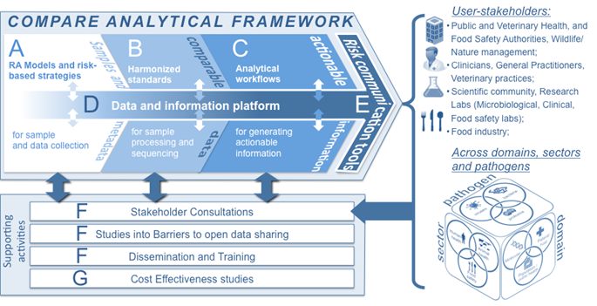

Annex I. Title
You can always add additional information in an annex.

